Oct 2026

Update the following Backlinks performance in the dashboard by considering the following parameters

Update the Number of URLS tracked, Total backlinks planned for Oct, actual backlinks acquired in Oct, and the number of keywords tracked to track performance

URLs Tracked - 46
PLAN TOTAL BACKLINKS (Oct) - 1390
Actual Total Backlinks (Oct) - 1170
Keywords Tracked - 82

Here are the Referring DA categories of the given backlinks
Referring Domain DA
DA 71–100: 160
DA 41–70: 834
DA 30–40: 176

Business Impact of Backlinks

1. Impact on Keywords Where Backlinks Are Acquired

Keywords in Top 3 Positions
Dec’25 - 7
Oct’26 -21

Keywords on First Page
Dec’25 -36
Oct'26 - 45

2. Impact on Overall Keyword Rankings Graph
Page 1 Baseline - 41683 Oct - 44298 (Row 16)
Position 1 Baseline - 6085 Oct - 6781 (Row 13)
Position 2 & 3 Baseline - 10662 Oct - 11859 (Row 14)

Backlink Growth Analysis

Here are all the page URLs tracked

- https://www.fortinet.com/resources/cyberglossary/what-is-ztna
- https://www.fortinet.com/resources/cyberglossary/what-is-network-security
- https://www.fortinet.com/resources/cyberglossary/what-is-cybersecurity
- https://www.fortinet.com/resources/cyberglossary/sd-wan-explained
- https://www.fortinet.com/resources/cyberglossary/sase
- https://www.fortinet.com/resources/cyberglossary/firewall
- https://www.fortinet.com/resources/cyberglossary/what-is-cyber-attack
- https://www.fortinet.com/solutions/industries/scada-industrial-control-systems/what-is-ot-security
- https://www.fortinet.com/products/sd-wan
- https://www.fortinet.com/resources/cyberglossary/what-is-secops
- https://www.fortinet.com/resources/cyberglossary/ransomware
- https://www.fortinet.com/resources/hubs/quantum-security
- https://www.fortinet.com/resources/cyberglossary/what-is-cloud-security
- https://www.fortinet.com/resources/cyberglossary/casb
- https://www.fortinet.com/solutions/enterprise-midsize-business/fortiai
- https://www.fortinet.com/resources/cyberglossary/ai-security
- https://www.fortinet.com/resources/cyberglossary/cyber-threat-intelligence
- https://www.fortinet.com/resources/cyberglossary/artificial-intelligence-in-cybersecurity
- https://www.fortinet.com/resources/cyberglossary/application-security
- https://www.fortinet.com/resources/cyberglossary/cloud-data-protection
- https://www.fortinet.com/resources/cyberglossary/privileged-access-management
- https://www.fortinet.com/
- https://www.fortinet.com/blog/industry-trends/quantum-safe-encryption-safeguarding-data-for-the-quantum-era
- https://www.fortinet.com/blog/business-and-technology/cyber-risk-is-a-business-risk
- https://www.fortinet.com/blog/industry-trends/cybersecurity-in-banking
- https://www.fortinet.com/resources/articles/best-cloud-security-providers
- https://www.fortinet.com/resources/cyberglossary/network-monitoring
- https://www.fortinet.com/resources/cyberglossary/shors-grovers-algorithms
- https://www.fortinet.com/resources/cyberglossary/post-quantum-cryptography
- https://www.fortinet.com/resources/cyberglossary/quantum-computing-security
- https://www.fortinet.com/resources/cyberglossary/quantum-key-distribution
- https://www.fortinet.com/resources/cyberglossary/quantum-safe-security
- https://www.fortinet.com/resources/cyberglossary/quantum-security
- https://www.fortinet.com/resources/cyberglossary/what-is-soc
- https://www.fortinet.com/solutions/unified-sase
- https://www.fortinet.com/products/rugged
- https://www.fortinet.com/resources/cyberglossary/what-is-zero-trust
- https://www.fortinet.com/solutions/ai-security
- https://www.fortinet.com/solutions/cloud-security/enterprise
- https://www.fortinet.com/resources/cyberglossary/what-is-soar
- https://www.fortinet.com/products/siem/fortisiem
- https://www.fortinet.com/solutions/security-operations
- https://www.fortinet.com/resources/cyberglossary/malware
- https://www.fortinet.com/resources/cyberglossary/proxy-firewall
- https://www.fortinet.com/resources/cyberglossary/proxy-server

Here are the Months they are tracked for
Jan’26 Feb’26 Mar’26 Apr’26 May’26 Jun’26 Jul’26 Aug’26 Sep’26Oct’26
Here are the Total Backlinks added, respectively, for each month
50
153
211
285
390
425
678
816
993
1170

Keyword Ranking Performance
Keywords in the Top 3 Positions after acquiring backlinks in the month
Dec’25 - 6
Oct’26 -21

Position change data - For the table below
Dec 2025
what is ztna 7
what is network security 15
What is SD WAN 8
sd wan 6
sase 7
what is sase 11
firewall 7
what is firewall 8
what is cyber attack 8
what is ot security 8
ot security 9
secure sd wan 16
what is secops 22
AI Cybersecurity 3
role of ai in cyber security 101
Quantum Safe Encryption 5
cloud security vendors 9
network monitoring system 29
Quantum Computing Security 101
Proxy Firewall 6
Proxy server 1

Keywords in Top 3 Positions after acquiring the backlinks in the month

Oct 2026
what is ztna 3
what is network security 2
What is SD WAN 2
sd wan 3
sase 2
what is sase 1
firewall 3
what is firewall 3
what is cyber attack 2
what is ot security 1
ot security 2
secure sd wan 1
what is secops 1
AI Cybersecurity 3
role of ai in cyber security 1
Quantum Safe Encryption 2
cloud security vendors 3
network monitoring system 2
Quantum Computing Security 1
Proxy Firewall 2
Proxy server 2
Keywords on first page after acquiring backlinks in the month
Dec’25 -35
Oct'26 - 45
Position Change Data - For the table below
Keywords on the first page after acquiring backlinks in the month
Dec 2025
what is ztna 7
ZTNA 16
what is network security 15
network security 13
what is cybersecurity 11
cybersecurity 10
What is SD WAN 8
sd wan 6
sase 7
what is sase 11
firewall 7
what is firewall 8
what is cyber attack 8
cyber attack 7
what is ot security 8
ot cyber security 5
ot security 9
secure sd wan 16
what is secops 22
secops 14
what is ransomware 9
ransomware 7
casb 10
casb security 18
AI Security 8
what is ai security 7
AI Security systems 8
AI Cybersecurity 3
role of ai in cyber security 101
Application security definition 14
Privileged Access Management 12
PAM 5
Quantum Safe Encryption 5
cloud security vendors 9
cloud security providers 5
network monitoring system 29
pqc 10
Quantum Computing Security 101
Quantum Key Distribution 4
Quantum Security 8
soar automation 2
siem products 8
siem solution 11
Proxy Firewal l 6
Proxy server 0

Oct 2026 -
what is ztna 3
ZTNA 7
what is network security 2
network security 7
what is cybersecurity 10
cybersecurity 4
What is SD WAN 2
sd wan 3
sase 2
what is sase 1
firewall 3
what is firewall 3
what is cyber attack 2
cyber attack 8
what is ot security 1
ot cyber security 7
ot security 2
secure sd wan 1
what is secops 1
secops 6
what is ransomware 7
ransomware 8
casb 5
casb security 5
AI Security 7
what is ai security 6
AI Security systems 7
AI Cybersecurity 3
role of ai in cyber security 1
Application security definition 8
Privileged Access Management 9
PAM 9
Quantum Safe Encryption 2
cloud security vendors 3
cloud security providers 5
network monitoring system 2
pqc 8
Quantum Computing Security 1
Quantum Key Distribution 5
Quantum Security 4
soar automation 4
siem products 6
siem solution 7
Proxy Firewall 2
Proxy server 2

Performance Summary Table
Update the summary table using this data
Page URLs (46 Page URLs)
- https://www.fortinet.com/resources/cyberglossary/what-is-ztna
- https://www.fortinet.com/resources/cyberglossary/what-is-network-security
- https://www.fortinet.com/resources/cyberglossary/what-is-cybersecurity
- https://www.fortinet.com/resources/cyberglossary/sd-wan-explained
- https://www.fortinet.com/resources/cyberglossary/sase
- https://www.fortinet.com/resources/cyberglossary/firewall
- https://www.fortinet.com/resources/cyberglossary/what-is-cyber-attack
- https://www.fortinet.com/solutions/industries/scada-industrial-control-systems/what-is-ot-security
- https://www.fortinet.com/products/sd-wan
- https://www.fortinet.com/resources/cyberglossary/what-is-secops
- https://www.fortinet.com/resources/cyberglossary/ransomware
- https://www.fortinet.com/resources/hubs/quantum-security
- https://www.fortinet.com/resources/cyberglossary/what-is-cloud-security
- https://www.fortinet.com/resources/cyberglossary/casb
- https://www.fortinet.com/solutions/enterprise-midsize-business/fortiai
- https://www.fortinet.com/resources/cyberglossary/ai-security
- https://www.fortinet.com/resources/cyberglossary/cyber-threat-intelligence
- https://www.fortinet.com/resources/cyberglossary/artificial-intelligence-in-cybersecurity
- https://www.fortinet.com/resources/cyberglossary/application-security
- https://www.fortinet.com/resources/cyberglossary/cloud-data-protection
- https://www.fortinet.com/resources/cyberglossary/privileged-access-management
- https://www.fortinet.com/
- https://www.fortinet.com/blog/industry-trends/quantum-safe-encryption-safeguarding-data-for-the-quantum-era
- https://www.fortinet.com/blog/business-and-technology/cyber-risk-is-a-business-risk
- https://www.fortinet.com/blog/industry-trends/cybersecurity-in-banking
- https://www.fortinet.com/resources/articles/best-cloud-security-providers
- https://www.fortinet.com/resources/cyberglossary/network-monitoring
- https://www.fortinet.com/resources/cyberglossary/shors-grovers-algorithms
- https://www.fortinet.com/resources/cyberglossary/post-quantum-cryptography
- https://www.fortinet.com/resources/cyberglossary/quantum-computing-security
- https://www.fortinet.com/resources/cyberglossary/quantum-key-distribution
- https://www.fortinet.com/resources/cyberglossary/quantum-safe-security
- https://www.fortinet.com/resources/cyberglossary/quantum-security
- https://www.fortinet.com/resources/cyberglossary/what-is-soc
- https://www.fortinet.com/solutions/unified-sase
- https://www.fortinet.com/products/rugged
- https://www.fortinet.com/resources/cyberglossary/what-is-zero-trust
- https://www.fortinet.com/solutions/ai-security
- https://www.fortinet.com/solutions/cloud-security/enterprise
- https://www.fortinet.com/resources/cyberglossary/what-is-soar
- https://www.fortinet.com/products/siem/fortisiem
- https://www.fortinet.com/solutions/security-operations
- https://www.fortinet.com/resources/cyberglossary/malware
- https://www.fortinet.com/resources/cyberglossary/proxy-firewall
- https://www.fortinet.com/resources/cyberglossary/proxy-server

The following is the original data. I want you to add a + next to the Best Keyword Move column for all data in the dashboard (not here). Also, for Worst Keyword Move, I want you to subtract the last column from the first column( ex: For ZTNA 8-33= -25). I want you to do the same for all the rows here as well
For the given URLs above, here are the Total Backlinks, Ranking & Page Authority & Backlinks Added for months
Dec’25 Jan’26 Feb’26 Mar’26 Apr’26 May’26 June’26Jul’26Aug’26 Sep’26OCt’26

Total Backlinks 0 0 7 13 14 21 23 29 33 33 34
Backlink Added 0 0 7 6 1 7 2 6 4 0 1
what is ztna 7 10 6 5 3 3 2 2 2 1 3
ZTNA 16 10 12 11 7 10 13 10 9 11 7
Page Authority 48 48 53 53 53 53 53 53 53 53 53

Total Backlinks 0 0 3 5 8 11 0 17 17 20 27
Backlink Added 0 0 3 2 3 3 0 6 0 3 7
what is network security 15 11 7 4 3 2 4 5 5 2 2
network security 13 14 10 8 6 4 10 14 13 8 7
Page Authority 53 53 53 53 53 53 53 53 53 53 53

Total Baclinks 0 0 4 6 10 16 0 21 0 26 27
Backlink Added 0 0 4 2 4 6 0 5 0 5 1
what is cybersecurity 11 13 10 9 10 10 10 12 12 11 10
cybersecurity 10 10 8 6 5 6 10 6 7 4 4
Page Authority 52 52 52 52 53 53 53 53 53 53 53

Total Baclinks 0 1 6 7 11 15 16 26 0 38 39
Backlink Added 0 1 5 1 4 4 1 10 0 12 1
What is SD WAN 8 7 6 5 4 3 2 3 3 2 2
sd wan 6 5 5 5 4 3 4 5 6 3 3
Page Authority 55 55 55 55 55 55 55 55 55 55 55

Total Baclinks 0 1 5 12 16 21 24 30 35 36 36
Backlink Added 0 1 4 7 4 5 3 6 5 1 0
sase 7 8 5 5 2 2 2 2 2 2 2
what is sase 11 12 8 6 3 2 2 2 2 1 1
Page Authority 56 56 56 56 56 56 56 56 56 56 56

Total Baclinks 0 0 4 6 8 11 12 24 30 41 49
Backlink Added 0 0 4 2 2 3 1 12 6 11 8
firewall 7 7 6 4 3 2 3 2 2 2 3
what is firewall 8 6 4 5 3 3 4 5 5 4 3
Page Authority 56 56 55 55 56 56 56 56 56 56 56

Total Baclinks 0 1 1 1 1 1 1 1 1 1 1
Backlink Added 0 1 0 0 0 0 0 0 0 0 0
what is cyber attack 8 7 1 2 2 2 2 3 2 2 2
cyber attack 7 8 9 8 6 6 6 8 9 8 8
Page Authority 50 50 51 51 51 51 51 51 51 51 51

Total Backlinks 0 1 4 5 7 12 12 24 24 27 37
Backlink Added 0 1 3 1 2 5 0 12 0 3 10
what is ot security 8 9 4 2 1 1 2 2 3 2 1
ot cyber security 5 11 4 3 4 5 12 22 11 5 7
ot security 9 9 5 4 2 2 2 2 2 2 2
Page Authority 55 55 55 55 55 55 55 55 55 55 55

Total Baclinks 0 1 1 1 1 5 5 16 22 34 37
Backlink Added 0 1 0 0 0 4 0 11 6 12 3
SD-WAN solutions 79 79 5 6 5 101 101 101 1 101 101
secure sd wan 16 15 2 1 1 1 1 4 5 6 1
Page Authority 59 59 59 59 59 59 59 59 59 59 59

Total Backlinks 0 0 5 6 11 16 21 28 35 37 39
Backlink Added 0 0 5 1 5 5 5 7 7 2 2
what is secops 22 17 7 3 4 2 2 2 5 1 1
secops 14 11 7 6 6 7 9 9 5 5 6
Page Authority 48 48 49 49 50 50 50 50 50 50 50

Total Backlinks 0 2 2 2 2 2 2 2 2 2 2
Backlink Added 0 2 0 0 0 0 0 0 0 0 0
what is ransomware 9 8 7 7 8 8 6 7 8 7 7
ransomware 7 6 7 5 4 6 7 8 9 8 8
Page Authority 56 56 57 57 57 57 57 57 57 57 57

Total Backlinks 0 0 1 2 2 2 2 2 2 2 2
Backlink Added 0 0 1 1 0 0 0 0 0 0 0
quantum security solutions 101 101 101 101 101 101 101 101 101 101 101
quantum security 101 1 101 101 1 101 101 101 101 101 101
Page Authority 41 41 43 43 44 44 44 44 44 44 44

Total Backlinks 0 4 23 31 44 53 54 71 96 115 130
Backlink Added 0 4 19 8 13 9 1 17 25 19 15
what is cloud security 19 15 13 9 12 17 16 16 23 15 19
cloud security 17 17 18 14 16 19 21 19 20 22 28
Page Authority 49 49 51 51 52 52 52 52 52 52 52

Total Backlinks 0 2 2 2 2 2 2 2 2 2 2
Backlink Added 0 2 0 0 0 0 0 0 0 0 0
casb 10 9 7 4 5 4 6 5 7 7 5
casb security 18 18 9 4 6 8 8 10 8 7 5
Page Authority 49 49 49 49 50 50 50 50 50 50 50

Total Backlinks 0 2 2 2 2 2 3 8 8 12 12
Backlink Added 0 2 0 0 0 0 1 5 0 4 0
ai cybersecurity solutions 101 101 101 101 101 101 101 101 101 101 101
ai managed security 101 101 101 101 101 101 101 101 101 101 101
Page Authority 49 49 37 37 52 52 52 52 52 52 52

Total Backlinks 0 12 15 16 18 20 20 28 30 31 32
Backlink Added 0 12 3 1 2 2 0 8 2 1 1
AI Security 8 10 11 8 12 18 16 11 11 9 7
what is ai security 7 7 8 10 11 12 14 13 8 5 6
AI Security systems 8 8 17 9 10 8 6 6 5 5 7
Page Authority 52 52 53 53 53 53 53 53 53 53 53

Total Backlinks 0 12 12 12 12 12 12 12 12 12 12
Backlink Added 0 12 0 0 0 0 0 0 0 0 0
Threat Intelligence 25 23 31 18 18 16 18 19 14 12 19
Types of threat intelligence 101 101 101 28 101 101 101 42 101 101 101
Page Authority 48 48 49 49 49 49 49 49 49 49 49

Total Backlinks 0 0 6 8 12 16 18 43 49 58 64
Backlink Added 0 0 6 2 4 4 2 25 6 9 6
AI Cybersecurity 3 3 4 3 3 3 5 2 2 3 3
role of ai in cybersecurity 101 14 101 101 2 1 2 1 1 1 1
Page Authority 55 55 55 55 55 55 55 55 55 55 55

Total Backlinks 0 2 2 2 2 2 2 2 2 2 2
Backlink Added 0 2 0 0 0 0 0 0 0 0 0
Application Security 18 19 16 18 16 16 20 20 26 17 16
Application security definition 14 19 17 5 5 4 5 7 8 8 8
Page Authority 41 41 46 46 46 46 46 46 46 46 46

Total Baclinks 0 1 5 7 9 13 13 18 25 33 39
Backlink Added 0 1 4 2 2 4 0 5 7 8 6
Cloud Data Security 66 62 31 25 34 40 35 29 47 47 50
cloud data protection 21 18 12 9 16 38 29 25 26 26 28
Page Authority 43 43 46 46 47 47 47 47 47 47 47

Total Backlinks 0 4 4 4 4 4 4 4 4 4 4
Backlink Added 0 4 0 0 0 0 0 0 0 0 0
Privileged Access Management 12 14 16 10 13 13 12 12 13 11 9
PAM 5 6 3 6 101 101 5 7 8 9 9
Page Authority 48 48 48 48 48 48 48 48 48 48 48

Total Backlinks 0 1 2 2 3 8 8 16 23 24 33
Backlink Added 0 1 1 0 1 5 0 8 7 1 9
Cybersecurity 86 89 86 67 35 27 29 12 16 11 14
What is Cybersecurity 101 101 101 101 101 101 101 101 101 101 101
Page Authority 68 68 69 69 69 69 69 69 69 69 69

Total Backlinks 0 0 2 3 4 6 6 12 13 15 17
Backlink Added 0 0 2 1 1 2 0 6 1 2 2
Quantum safe encryption for cryptography 101 101 101 101 101 101 101 101 101 101 101
Quantum Safe Encryption 5 4 101 3 4 29 14 101 7 5 2
Page Authority 60 60 47 47 47 47 47 47 47 47 47

Total Backlinks 0 2 2 2 2 2 2 2 2 2 2
Backlinks Added 0 2 0 0 0 0 0 0 0 0 0
cyber risk 40 41 40 32 37 101 50 101 81 101 38
cyber risk is business risk 101 101 101 101 101 101 101 101 101 101 101
Page Authority 44 44 46 46 46 46 46 46 46 46 46

Total Backlinks 0 1 1 1 1 1 1 1 1 1 1
Backlink Added 0 1 0 0 0 0 0 0 0 0 0
cybersecurity in banking 101 30 101 12 21 25 29 7 9 101 38
banking cybersecurity 101 101 101 3 101 28 101 14 22 101 101
Page Authority 44 44 44 44 46 46 46 46 46 46 46

Total Backlinks 0 0 7 8 17 17 17 17 17 17 17
Backlink Added 0 0 7 1 9 0 0 0 0 0 0
cloud security vendors 9 7 11 6 8 7 8 5 5 6 3
cloud security providers 5 7 9 5 8 9 3 8 7 6 5
Page Authority 61 61 61 61 44 44 44 44 44 44 44

Total Baclinks 0 0 3 4 7 11 11 14 14 18 22
Backlink Added 0 0 3 1 3 4 0 3 0 4 4
network monitoring 21 19 11 7 8 12 13 11 10 4 14
network monitoring system 29 19 19 14 11 10 10 4 4 3 2
Page Authority 44 44 44 44 45 45 45 45 45 45 45

Total Backlinks 0 0 3 5 6 9 11 22 24 28 34
Backlink Added 0 0 3 2 1 3 2 11 2 4 6
grover's algorithm 6 7 7 4 8 4 5 2 101 101 101
shors algorithms 101 101 101 101 101 101 101 101 101 101 101
Page Authority 46 46 47 47 47 47 47 47 47 47 47

Total Backlinks 0 0 4 6 7 10 11 18 22 25 32
Backlinks Added 0 0 4 2 1 3 1 7 4 3 7
pqc 10 11 11 5 7 14 16 16 8 9 8
Post-Quantum Cryptography 1 2 3 6 2 2 3 4 3 6 11
Page Authority 39 39 42 42 44 44 44 44 44 44 44

Total Backlinks 0 0 2 4 5 6 7 12 14 15 18
Backlink Added 0 0 2 2 1 1 1 5 2 1 3
Quantum Computing Security 101 4 5 6 101 7 4 1 2 1 1
Page Authority 46 47 47 47 47 47 47 47 47 47 47

Total Backlinks 0 0 1 5 5 6 10 15 19 22 23
Backlink Added 0 0 1 4 0 1 4 5 4 3 1
Quantum Key Distribution 4 8 8 5 4 5 5 4 2 3 5
Page Authority 61 61 61 61 44 44 44 44 44 44 44

Total Backlinks 0 0 2 3 5 7 7 12 13 14 17
Backlink Added 0 0 2 1 2 2 0 5 1 1 3
Quantum Safe Security 3 1 1 101 101 2 101 1 3 1 20
Page Authority 37 39 40 40 42 42 42 42 42 42 42

Total Backlinks 0 0 4 6 7 9 10 17 17 18 21
Backlink Added 0 0 4 2 1 2 1 7 0 1 3
Quantum Security 8 7 5 5 5 4 3 5 5 6 4
Page Authority 41 40 40 40 44 44 44 44 44 44 44

Total Backlinks 0 0 2 3 4 6 7 8 11 12 12
Backlink Added 0 0 2 1 1 2 1 1 3 1 0
Security Operation Centre 101 101 101 101 101 101 101 101 101 101 101
Page Authority 51 52 52 52 52 52 52 52 52 52 52

Total Backlinks 0 0 2 3 3 9 13 26 37 53 55
Backlinks Added 0 0 2 1 0 6 4 13 11 16 2
Unified SASE 1 1 1 1 1 6 3 3 1 1 13
Page Authority 37 40 41 41 44 44 44 44 44 44 44

Total Backlinks 0 0 2 5 6 8 10 12 18 22 23
Backlink Added 0 0 2 3 1 2 2 2 6 4 1
Ruggedized firewall 101 1 1 1 101 1 1 1 1 101 27
industrial firewall 2 2 1 3 1 1 1 20 101 101 101
Page Authority 44 44 44 44 44 44 44 44 44 44 44

Total Backlinks 0 0 0 0 4 5 6 20 34 48 67
Backlink Added 0 0 0 0 4 1 1 14 14 14 19
What is Zero Trust 101 101 101 101 101 101 101 49 46 31 31
Zero trust 101 101 101 61 57 24 101 59 68 74 34
Page Authority 42 42 42 42 42 42 42 42 42 42 42

Total Backlinks 0 0 0 0 2 4 4 4 4 4 4
Backlink Added 0 0 0 0 2 2 0 0 0 0 0
AI Security 101 57 36 19 28 35 101 63 8 17 11
Page Authority 43 43 43 43 43 43 44 44 44 44 44

Total Backlinks 0 0 0 0 0 6 6 19 27 49 53
Backlink Added 0 0 0 0 0 6 0 13 8 22 4
Cloud Security Services 101 101 101 101 101 101 101 101 101 101 101
Cloud Security Solutions 101 101 101 101 101 101 101 101 101 101 101
Page Authority 37 37 37 37 37 39 41 41 41 41 41

Total Backlinks 0 0 0 0 0 0 1 2 4 6 8
Backlinks Added 0 0 0 0 0 0 1 1 2 2 2
Soar automation 2 3 1 4 1 4 10 5 3 4 4
Page Authority 61 61 61 61 61 61 61 61 61 61 61

Total Backlinks 0 0 0 0 0 0 0 14 25 35 40
Backlink Added 0 0 0 0 0 0 0 0 11 10 5
siem software 15 12 11 9 4 6 11 15 13 14 11
siem products 8 12 9 8 8 10 9 10 11 9 6
siem solution 11 11 8 4 3 7 11 11 8 8 7
Page Authority 61 61 61 61 61 61 61 61 61 61 61

Total Backlinks 0 0 0 0 0 0 0 6 12 17 17
Backlink Added 0 0 0 0 0 0 0 6 6 5 0
security operations solution 101 101 101 101 101 101 101 101 101 101 101
secops solutions 101 101 101 101 101 101 101 101 101 101 101
Page Authority 37 37 37 41 43 43 42 43 43 43 43

Total Backlinks 0 0 0 0 0 0 0 0 0 2 14
Backlink Added 0 0 0 0 0 0 0 0 0 2 12
Malware 8 9 7 8 6 7 11 7 12 13 12
Page Authority 61 61 61 61 61 61 61 61 61 61 61

Total Backlinks 0 0 0 0 0 0 0 0 0 2 2
Backlink Added 0 0 0 0 0 0 0 0 0 2 0
Proxy Firewall 6 9 6 2 2
Page Authority 53 53 53 53 53 53 53 53 53 54 54

Total Baclinks 0 0 0 0 0 0 0 0 0 1 4
Backlink Added 0 0 0 0 0 0 0 0 0 1 3
Proxy server 1 7 1 1 2 4 1 1 5 2 2
Page Authority 58 58 58 58 58 58 58 58 59 59 59

Key Findings
Include key findings from the data Insights
Insights
High-Quality Domain Profile: 71.3% of acquired referring domains fall in the DA 41–70 range (834 domains), representing the largest share of the portfolio. 15.0% are in the DA 30–40 range (176 domains), while 13.7% are high-authority DA 71–100 domains (160 domains). Overall, 85.0% of referring domains have a DA of 41 or higher, indicating a strong domain authority profile.
Keyword Visibility: From December 2025 to October 2026, Top 3 rankings grew 250% (from 6 to 21), and Page 1 rankings grew 28.6% (from 35 to 45).
Page Authority Improvements Across Tracked Pages: PA improved across several pages, including Ransomware (56 → 57), SecOps Solutions (37 → 43), What is Cybersecurity (52 → 53), Cyber Attack (50 → 51), Network Monitoring (44 → 45), Cloud Security Solutions (37 → 41), Proxy Firewall (53 → 54), and Quantum Safe Security (37 → 42).
Significant Keyword Improvement: The keywords role of AI in cyber security (101 → 1), Quantum Computing Security (101 → 1), what is SecOps (22 → 1), secure SD WAN (16 → 1), what is SASE (11 → 1), what is OT security (8 → 1), network monitoring system (29 → 2), what is network security (15 → 2), and what is cyber attack (8 → 2) showed significant improvements in search rankings.
Backlink Indexation Performance: 75.1% of acquired backlinks are indexed, indicating that the majority of acquired backlinks have been indexed by Google.
Backlink Acquisition Details
Fortinet: Monthly Backlink 2026
SERP Key Highlights:
Priority Category pages - Security Operations, firewall security, and zero day attack - moved into Page 1 positions following backlink-driven ranking improvements.

Keyword - Security Operations
Link - https://www.fortinet.com/resources/cyberglossary/what-is-secops
Position - 8
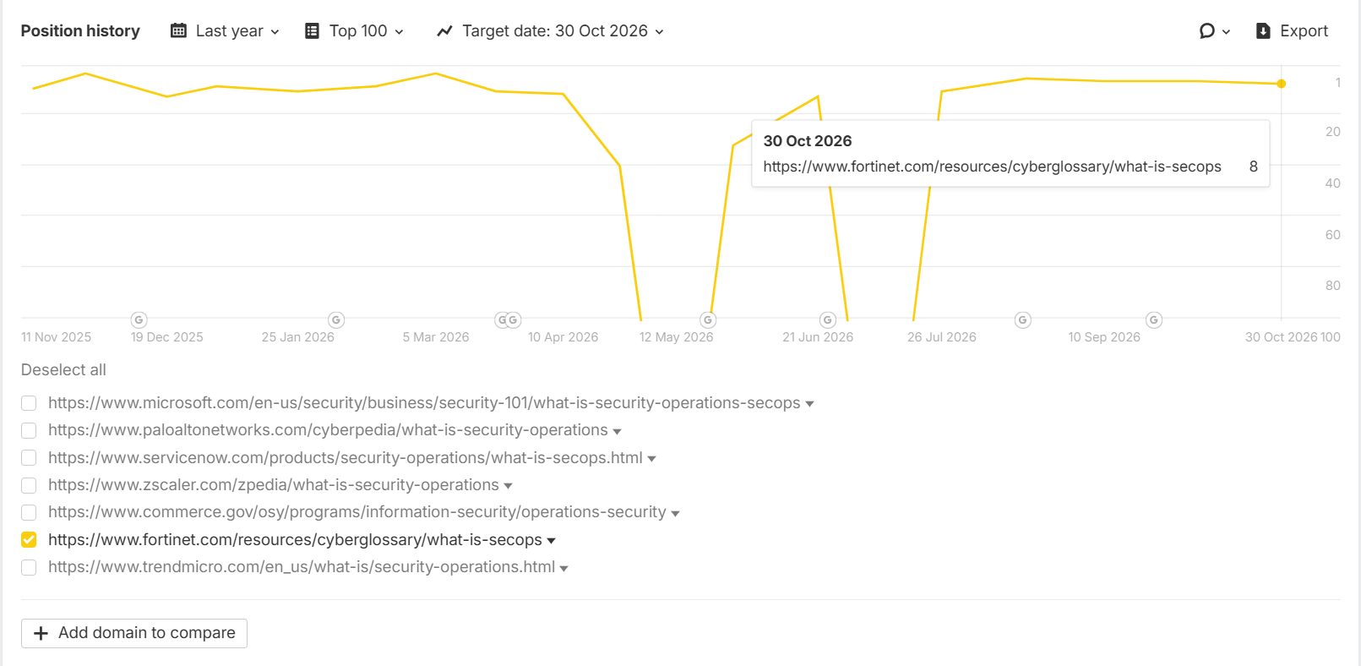

Insight: The "Security Operations" keyword has secured a Page 1 position at #8, placing the Fortinet SecOps page within the first 10 search results. Continued backlink acquisition and authority-building efforts can help improve rankings and push the page closer to the Top 5

Keyword - firewall security
Link - https://www.fortinet.com/resources/cyberglossary/firewall
Position - 4
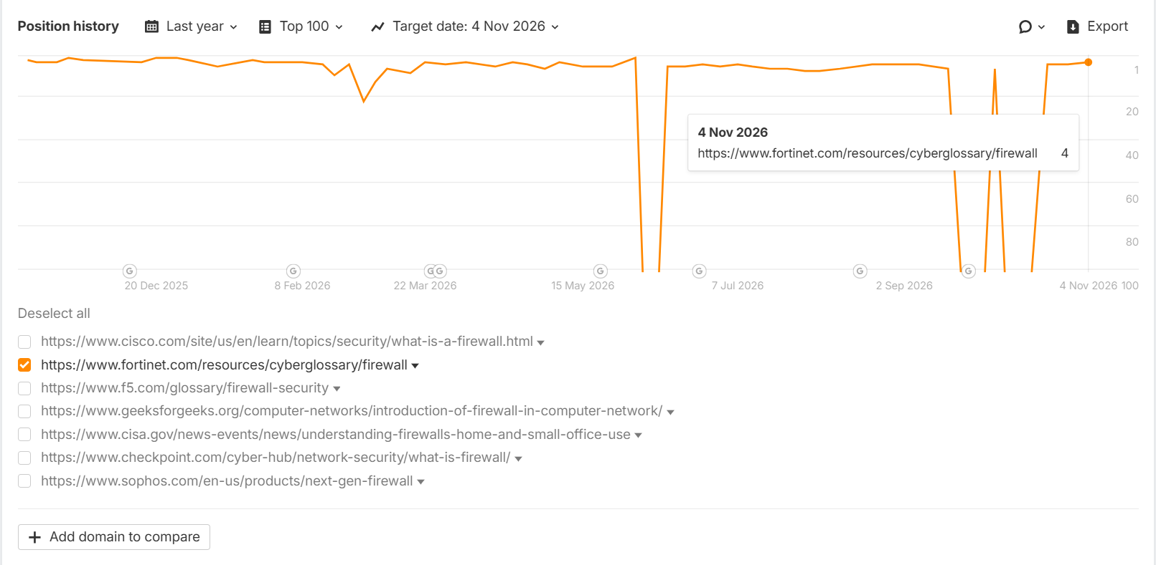
Insight: The "Firewall Security" keyword ranks at #4 on Page 1, with an opportunity to break into the Top 3 through continued backlink acquisition.

Keyword - zero day attack
Link - https://www.fortinet.com/resources/cyberglossary/zero-day-attack
Position - 5
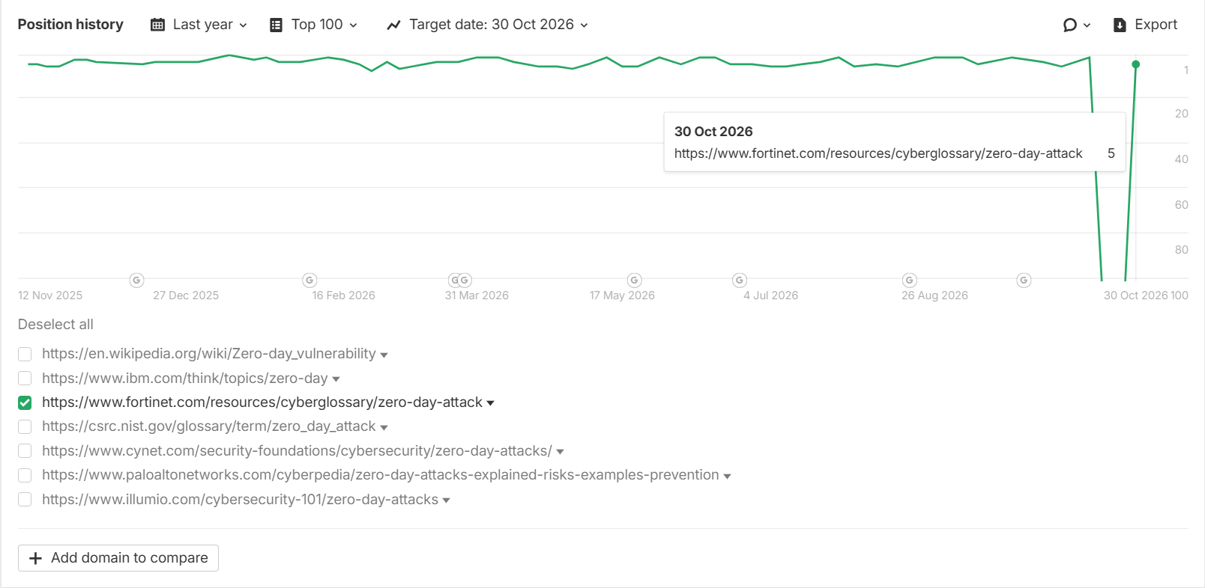
Insight: The “zero day attack” keyword demonstrated strong ranking stability, holding the #1 position for most of the year before a brief fluctuation and recovering to #5 by October 2026.

Top Categories - Quantum & AI Cybersecurity Cyberglossary pages rank in the Top 3 positions on Page 1 post-backlink efforts.
Keyword - qkd
Link- www.fortinet.com/resources/cyberglossary/quantum-key-distribution
Position - 1
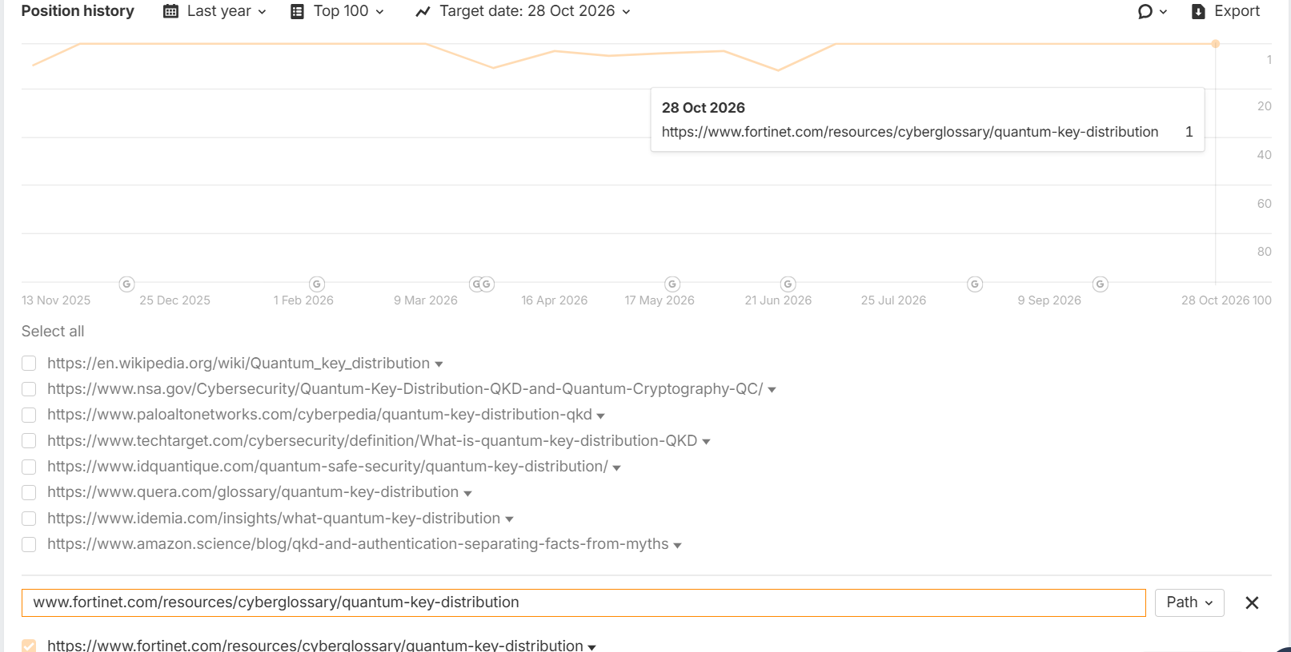

Insight: The “qkd” keyword maintains a strong #1 position, recovering quickly from minor dips earlier this year through continued backlink acquisition efforts.

Keyword - ai managed security
Link- https://www.fortinet.com/resources/cyberglossary/artificial-intelligence-in-cybersecurity
Position - 3

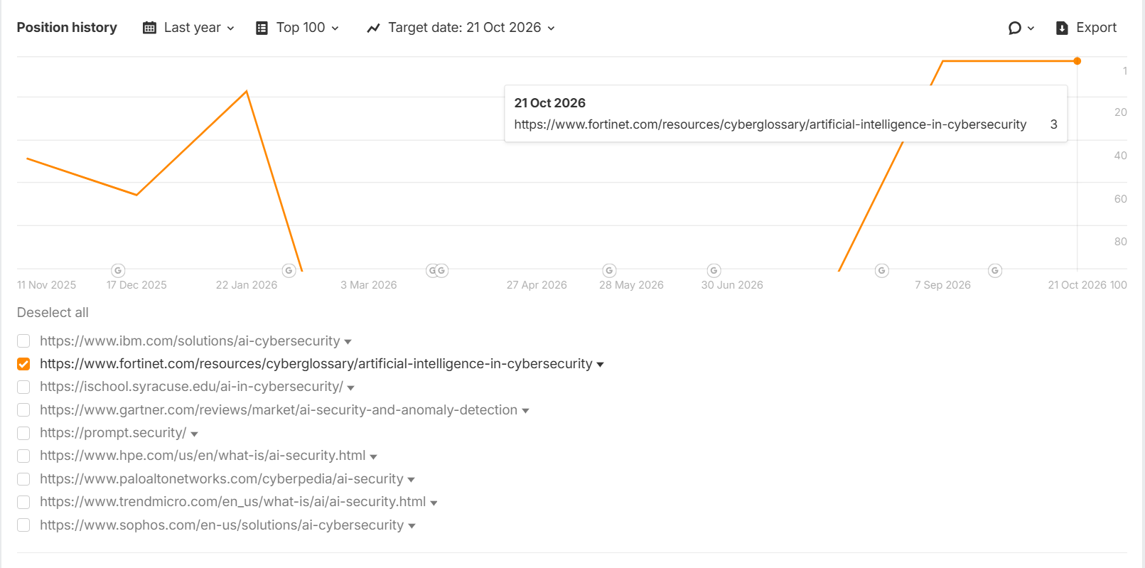

Insight: The “ai managed security” keyword has improved from outside the top 100 to #3 in recent months, maintaining its strong position through continued backlink acquisition efforts.

Keyword - ai cybersecurity
Link- https://www.fortinet.com/resources/cyberglossary/artificial-intelligence-in-cybersecurity
Position - 1
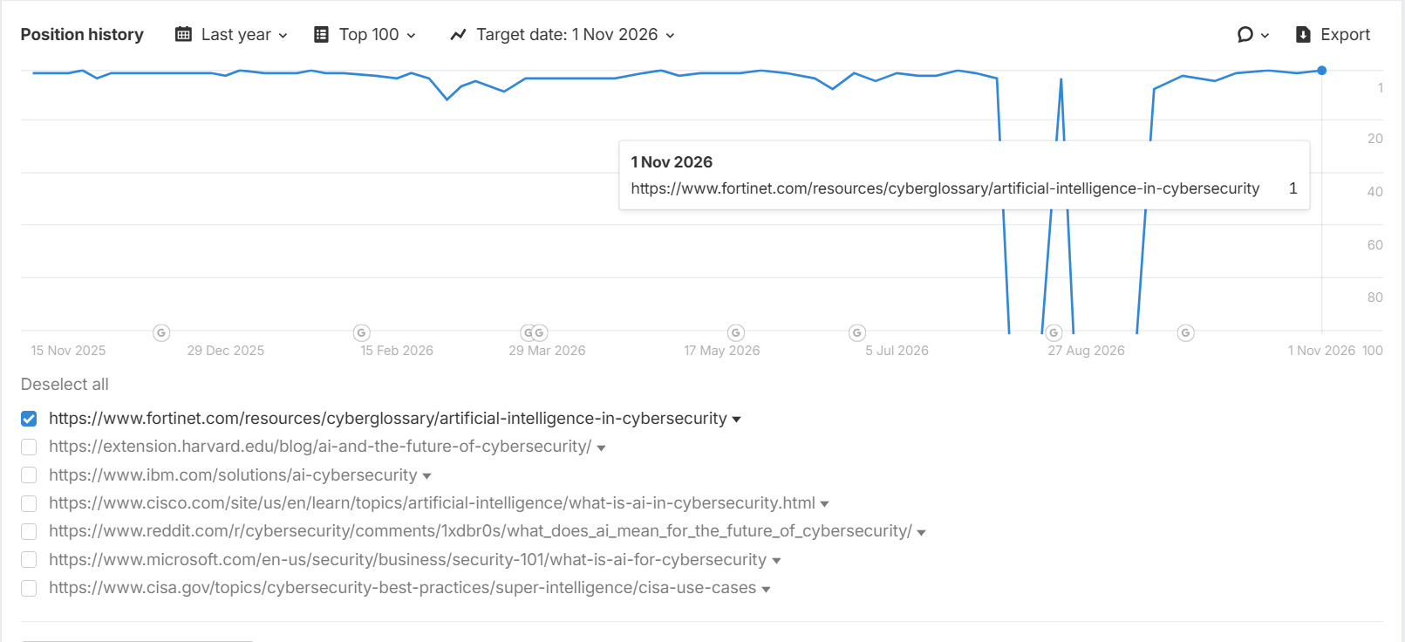

Insight: The "ai cybersecurity" keyword has achieved a #1 ranking, giving Fortinet maximum search visibility and strengthening its authority in the AI-driven cybersecurity category.

LLM Key Highlights:
Brand Visibility% Performance
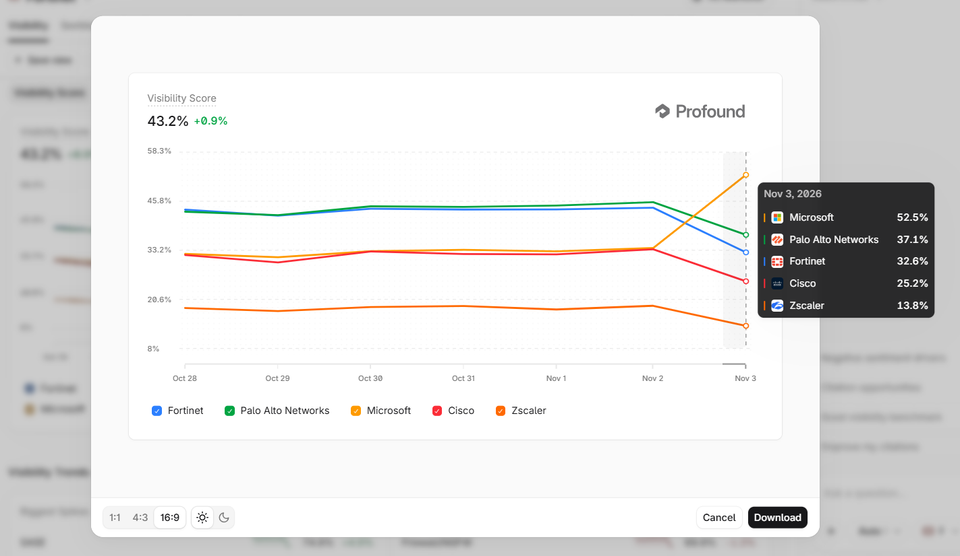
Insight: Fortinet ranks #3 in overall brand visibility at 32.6%, behind Microsoft (52.5%) and Palo Alto Networks (37.1%), after holding around 44% earlier in the week.

Category Brand Visibility Performance
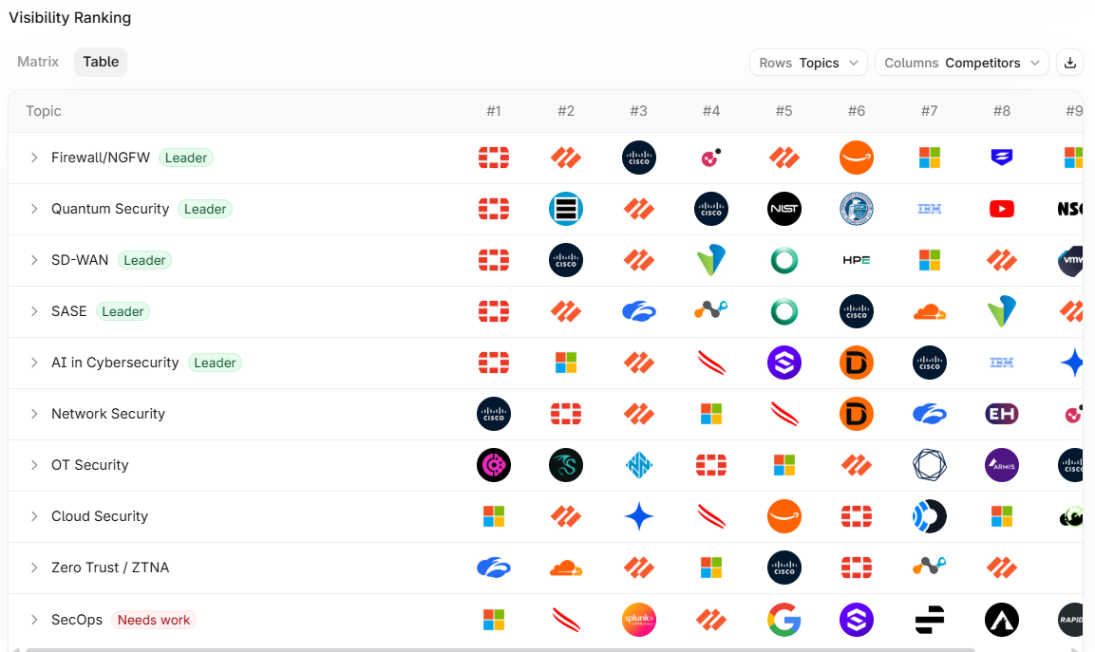
Insight:
Fortinet leads in 5 out of 10 primary categories, achieving a 50% category leadership rate, demonstrating strong authority across key cybersecurity topics such as Firewall/NGFW, Quantum Security, SD-WAN, SASE, and AI in Cybersecurity.

Category Matrix - Market Positioning
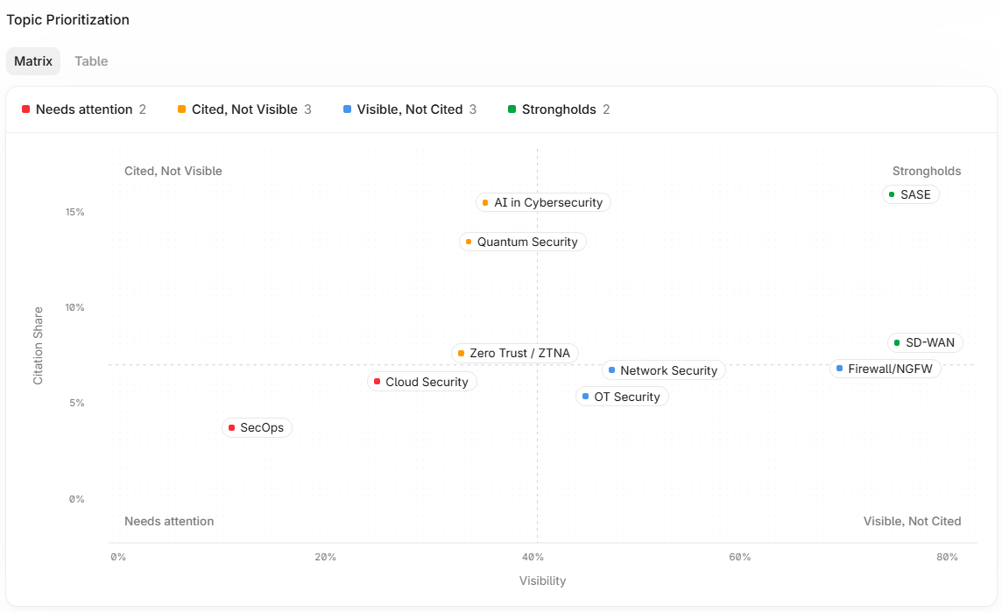
Insight: Fortinet's LLM Marketing positioning
- Citation Leaders - AI in Cybersecurity, Quantum Security & Zero Trust/ZTNA.
- Visibility Leaders - Network Security, Firewall/NGFW & OT Security
- Strongholds - SASE & SD-WAN
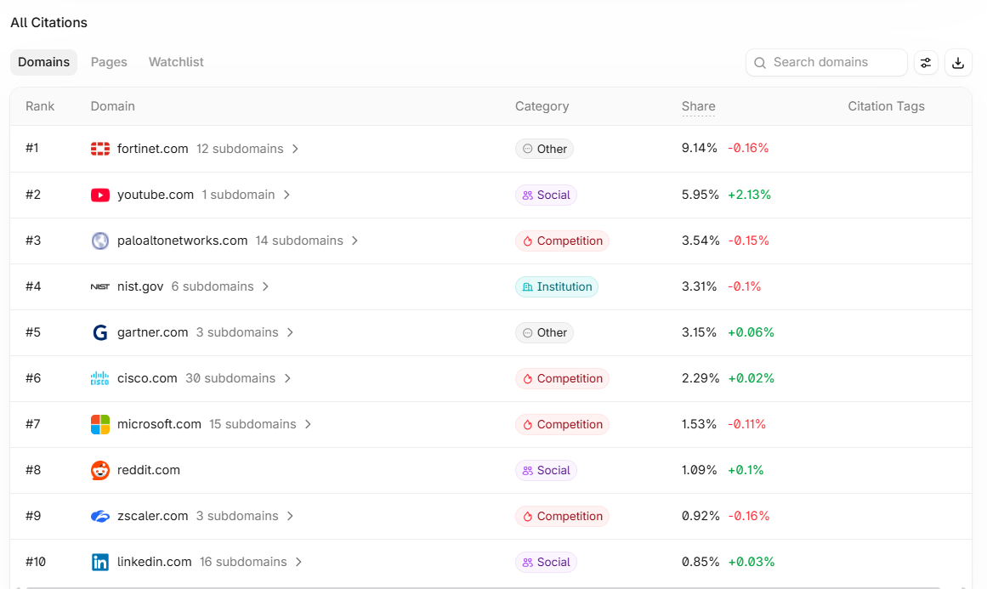
Top citation domains landscape:
Insight: Fortinet ranks #1 in the citation domains with a share of 9.14%, outperforming Palo Alto Networks (3.54%) and maintaining a strong lead over all major competitors.

Listicle-type Guest Posts - Third-Party Guest Posts for Brand Mentions
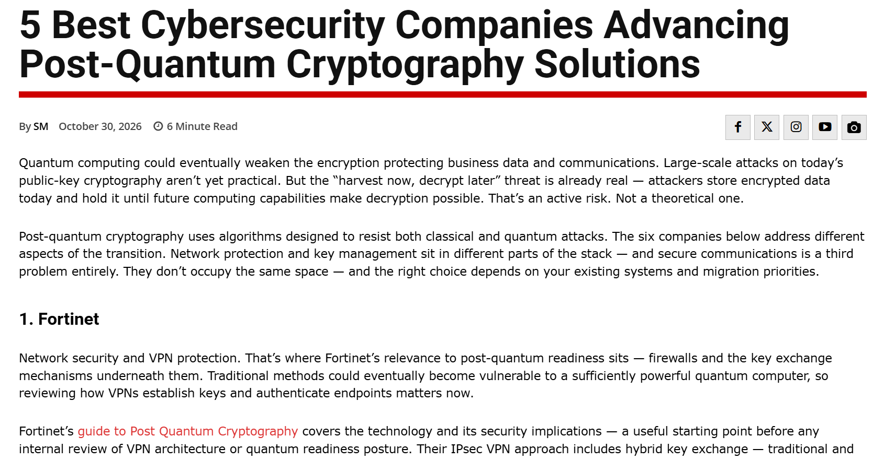
Full article -
5 Best Cybersecurity Companies Advancing Post-Quantum Cryptography Solutions - SpeedwayMedia.com
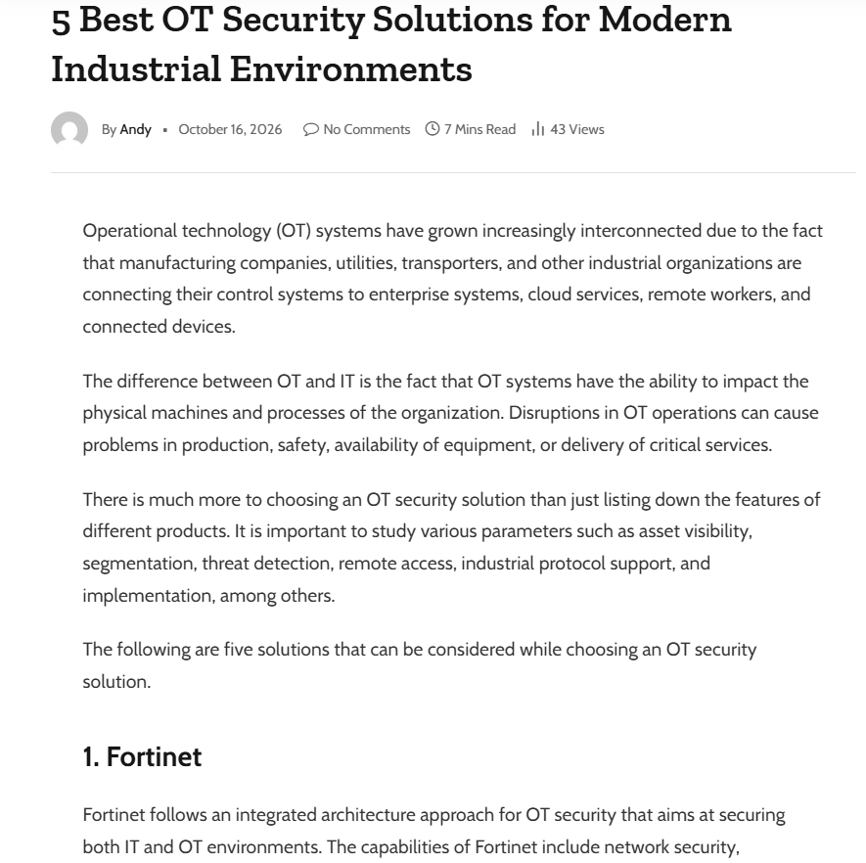
Full article - 5 Best OT Security Solutions for Modern Industrial Environments - iclmeaning.com
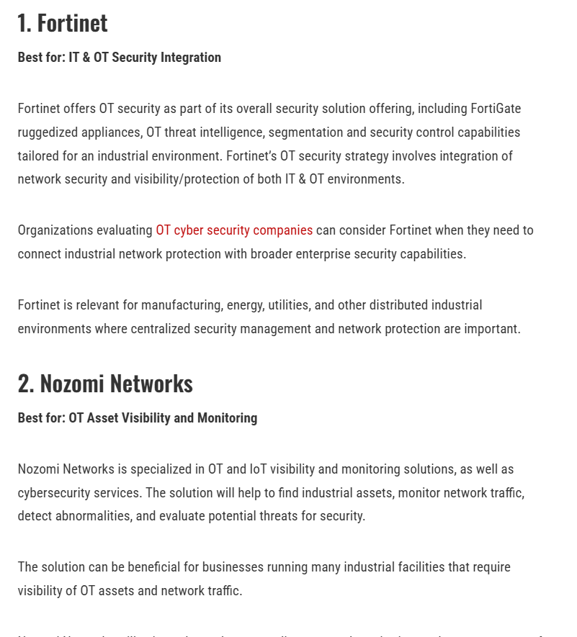
Full Article - 5 Leading OT Cyber Security Companies Protecting Modern Industrial Networks

Insight: Publishing listicle-style ("Best"/"Top") commercial-intent content to achieve a dual benefit: earning high-quality backlinks while increasing LLM visibility with brand mentions.

